14. Demonstrate Infrastructure as a Service (IaaS) by establishing the remote connection, launch the created VM image and run in your desktop…..

AT FIRST YOU NEED TO CREATE AN ACCOUNT OF MICROSOFT AZURE….

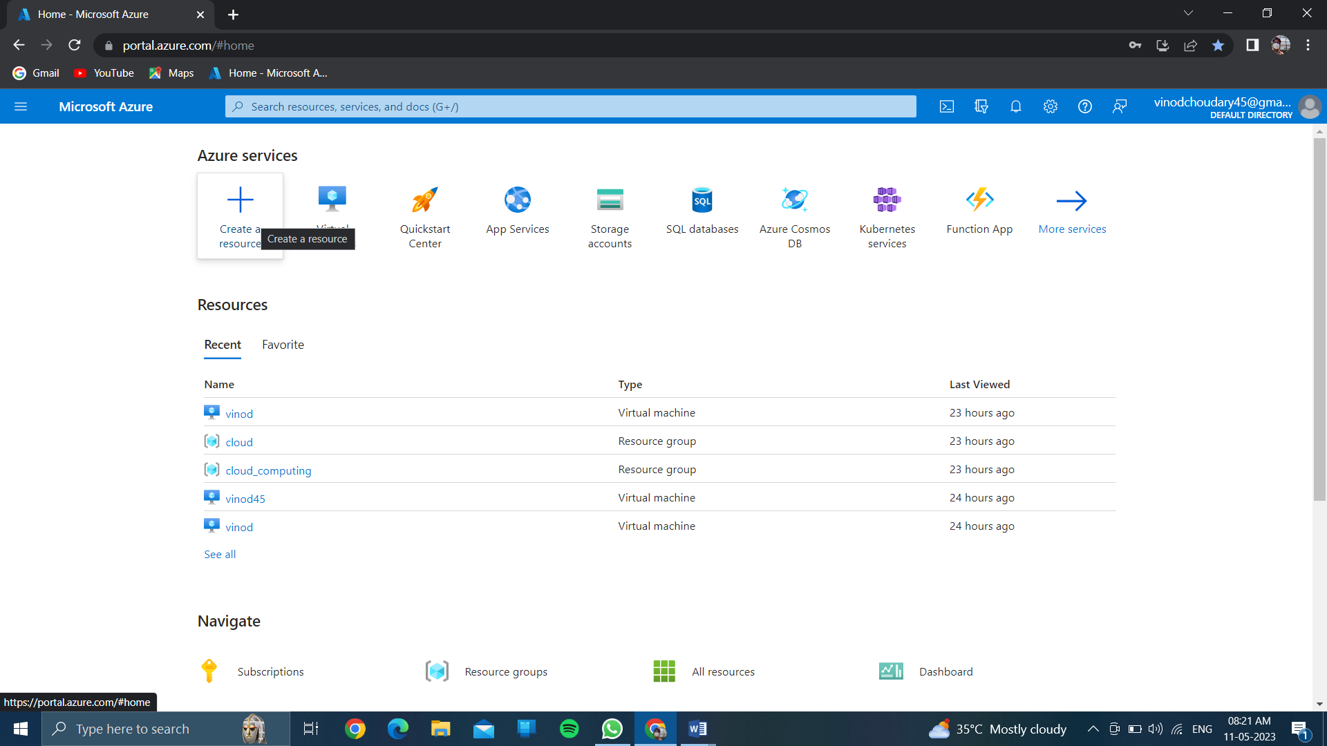

CLICK ON CREATE A RESOURCE…..

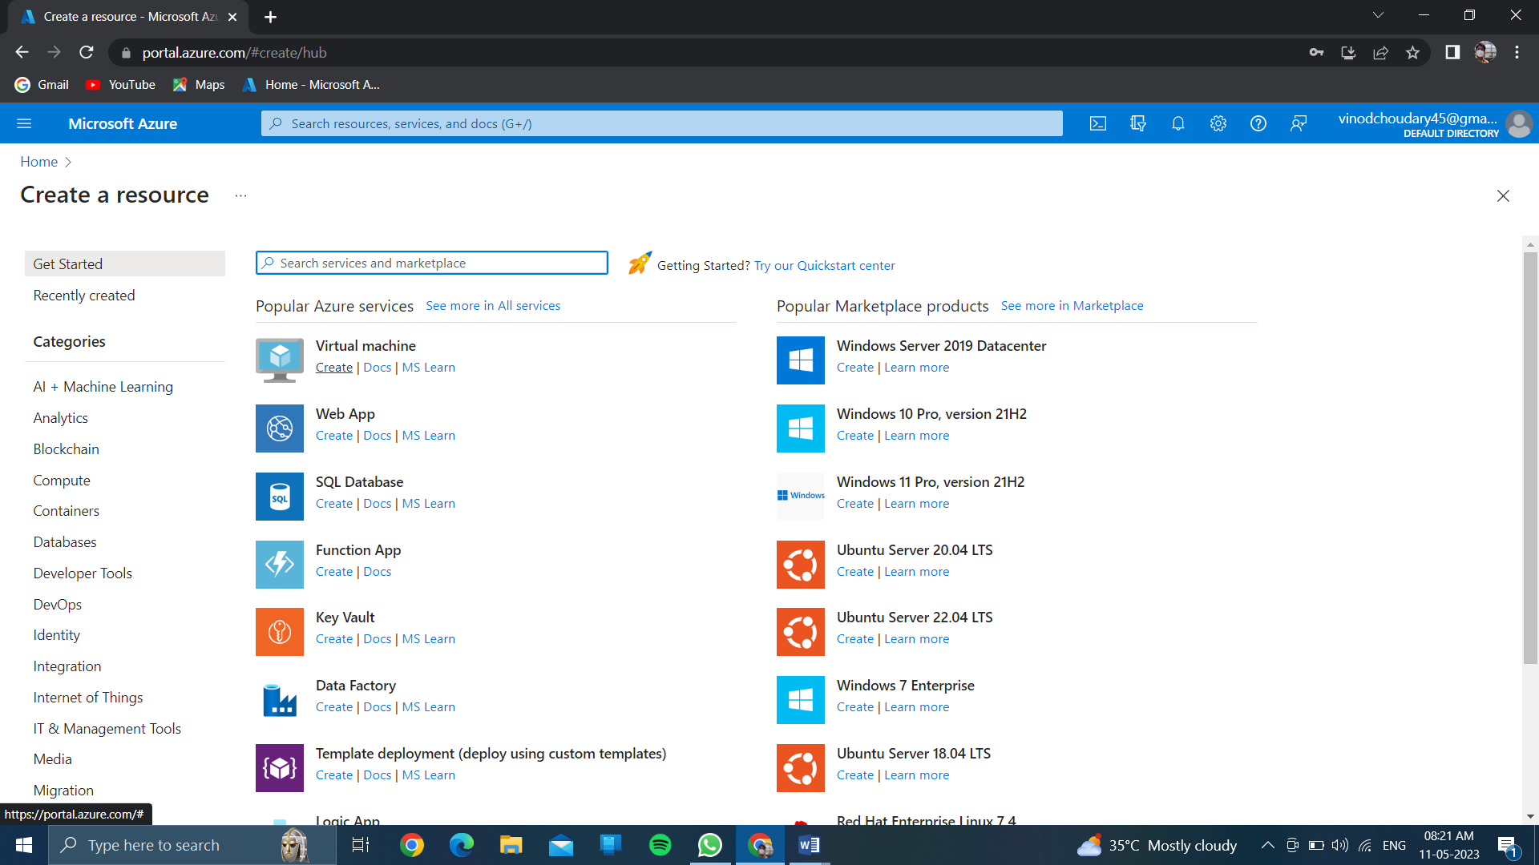

CLICK ON CREATE OF VIRTUAL MACHINE….

CREATE A RESOURCE GROUP…..

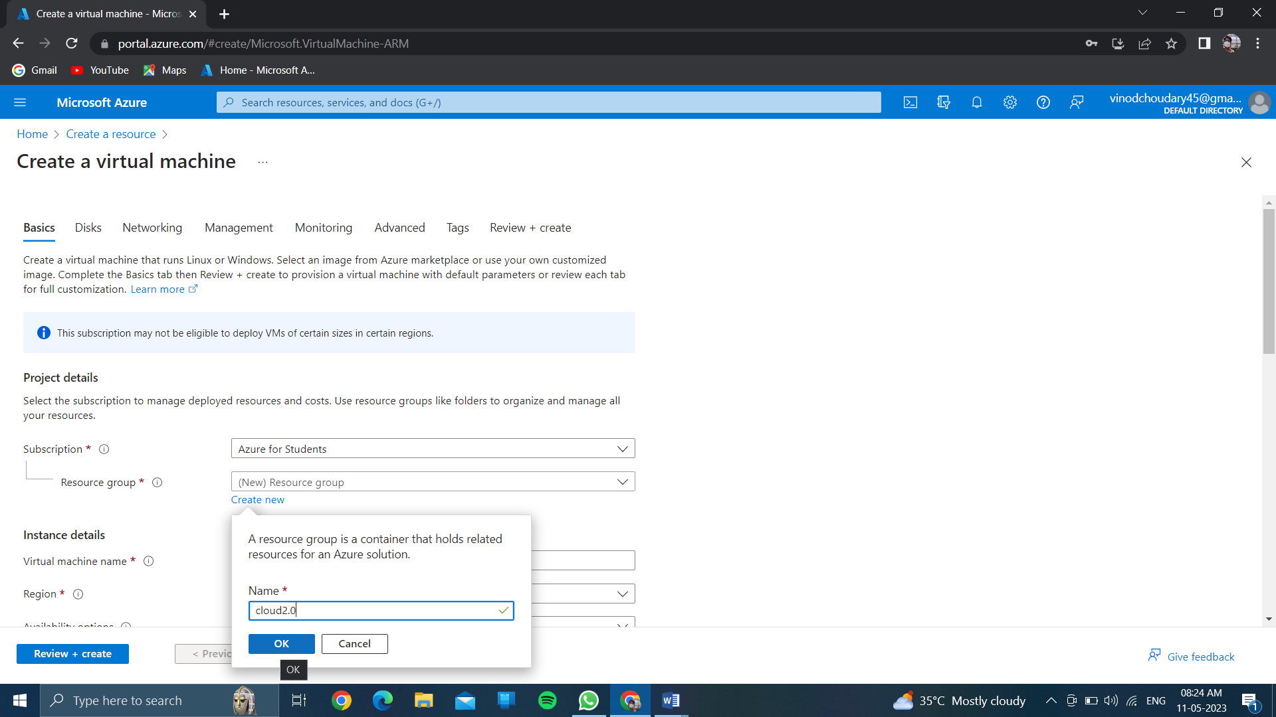

Give the name of virtual machine….

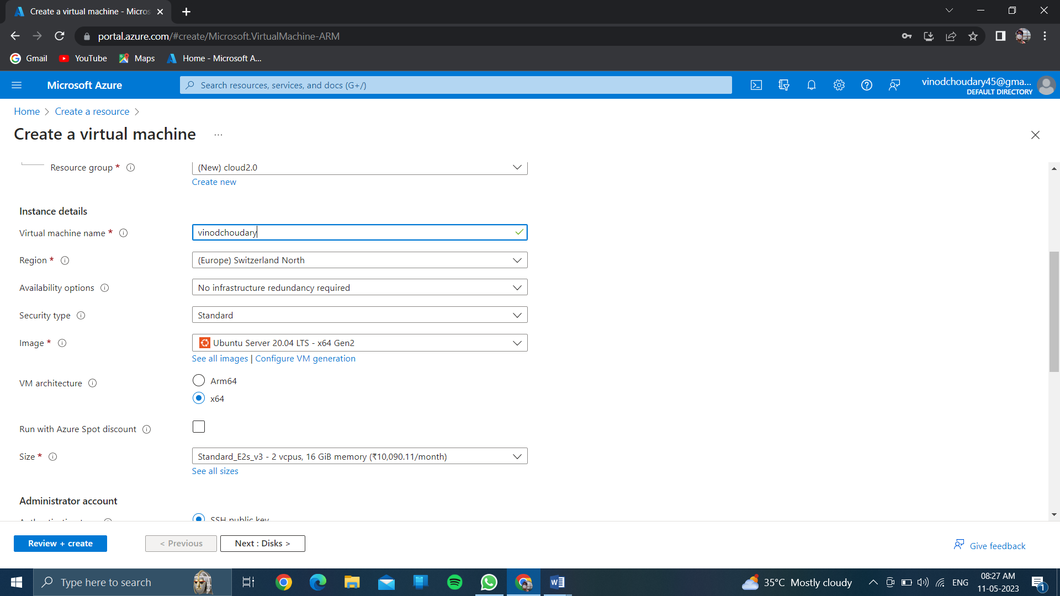

Choose any region………based on cpu & ram configuration of size….

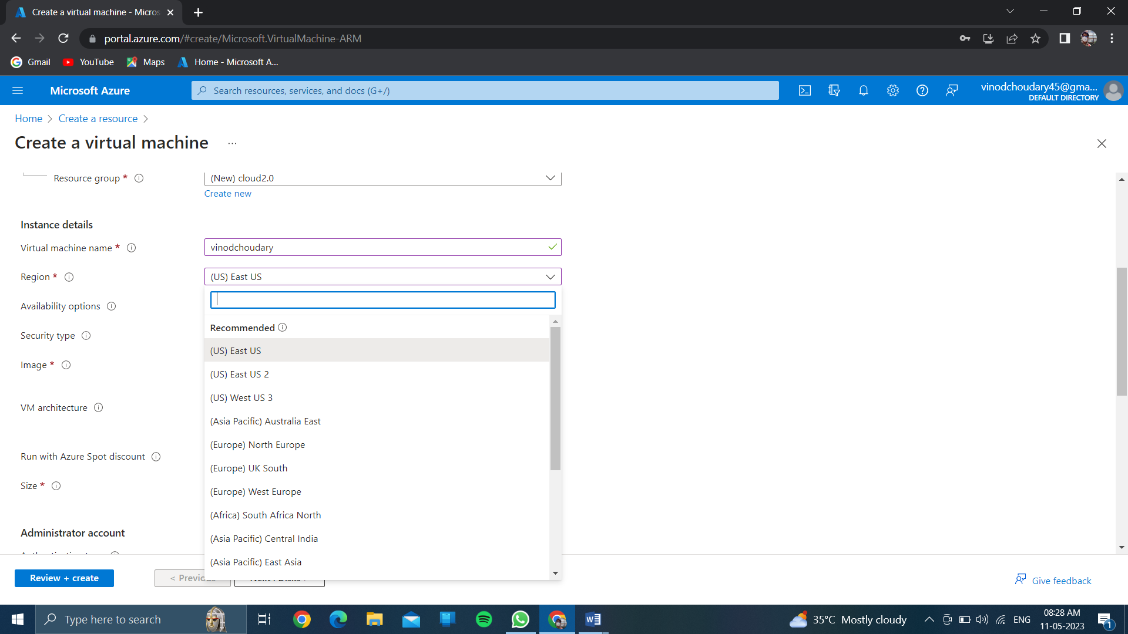

Click on authenticated type //and choose >>password<<

And create your own username and password…..

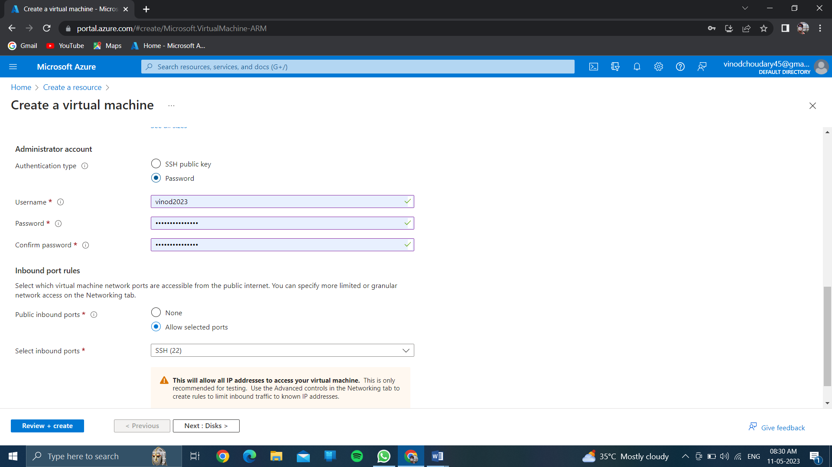

Click on<<review and create>>

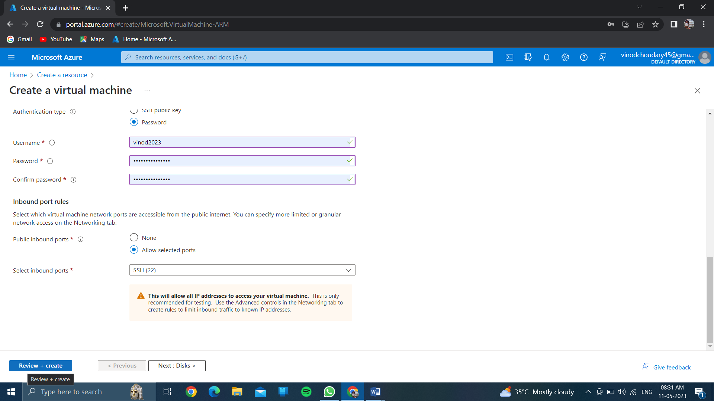

And wait few minutes for getting the validation passed…..

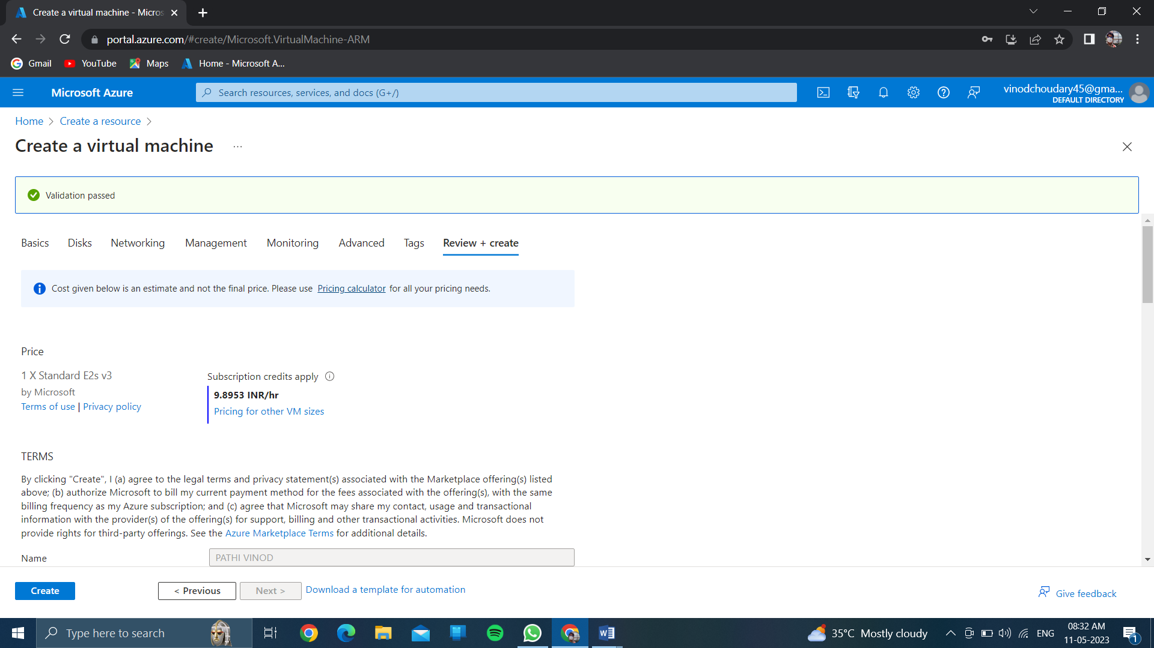

Click on create…..

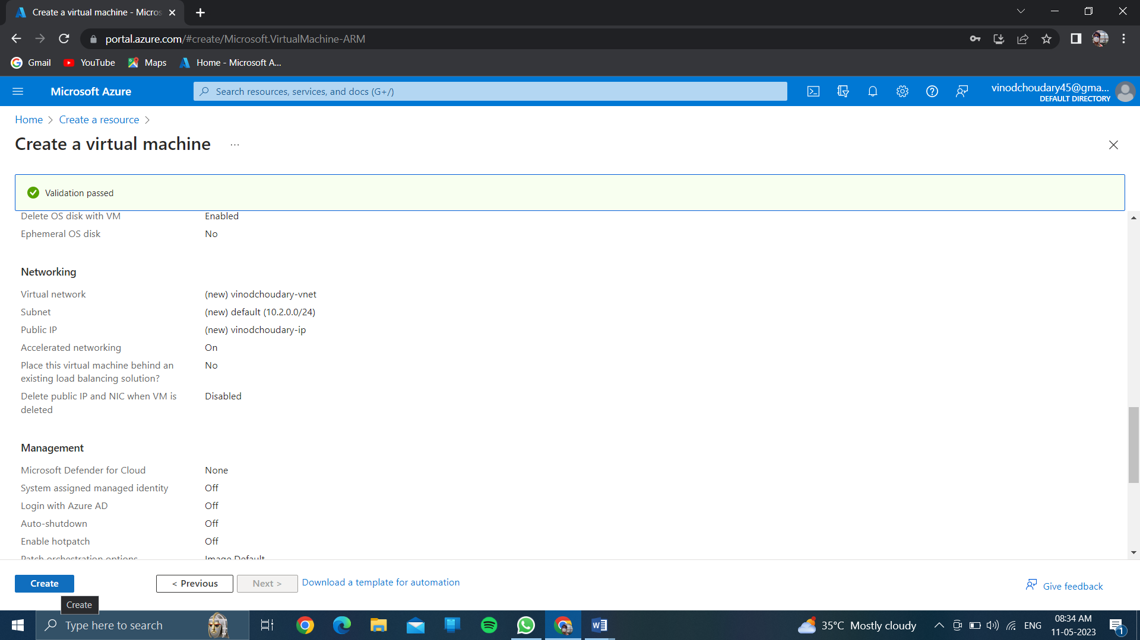

And wait for few minutes for complitation of deployment process>>

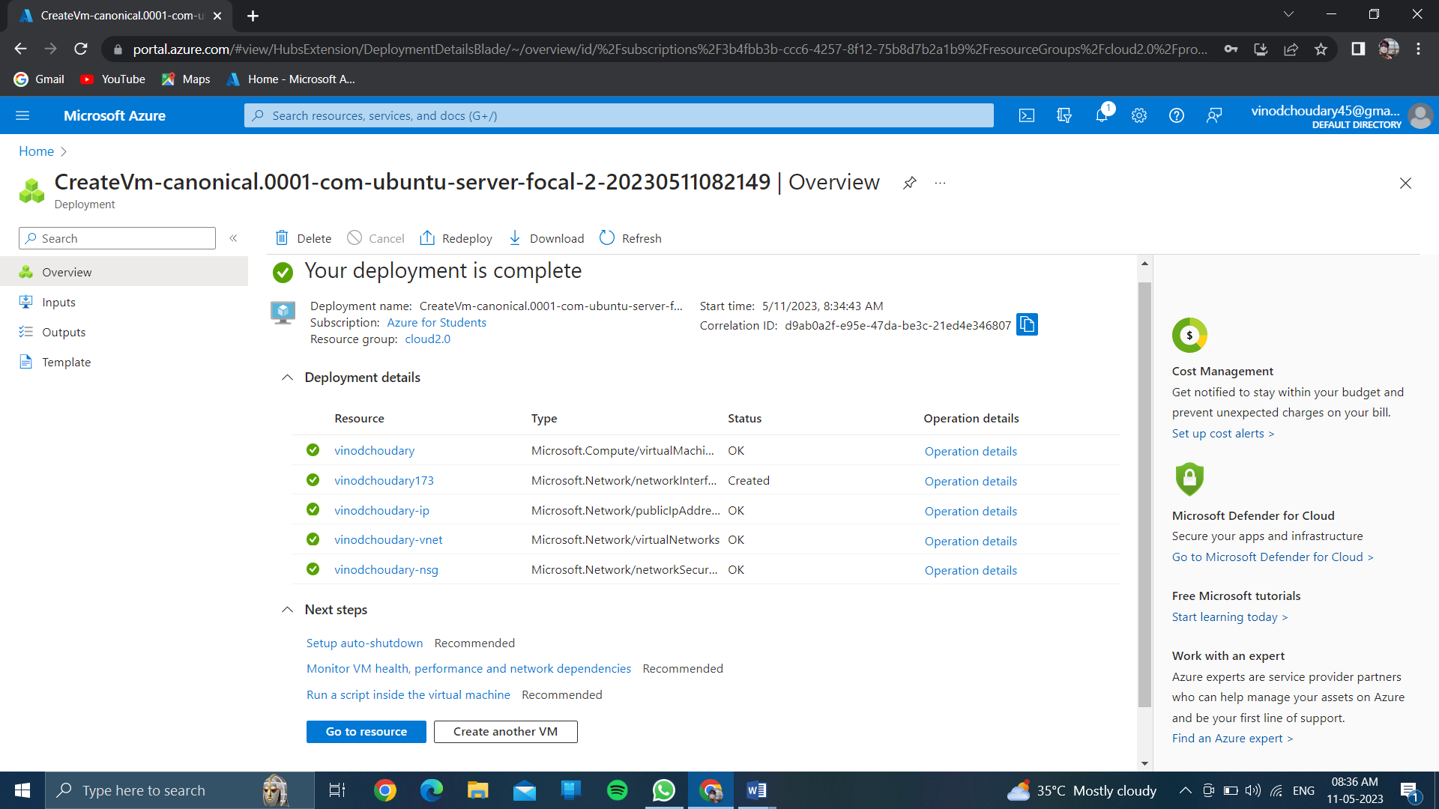Then after click on <<resource>>….

Then after click on <<create>>then see your resource group is created and virtual machine also…..

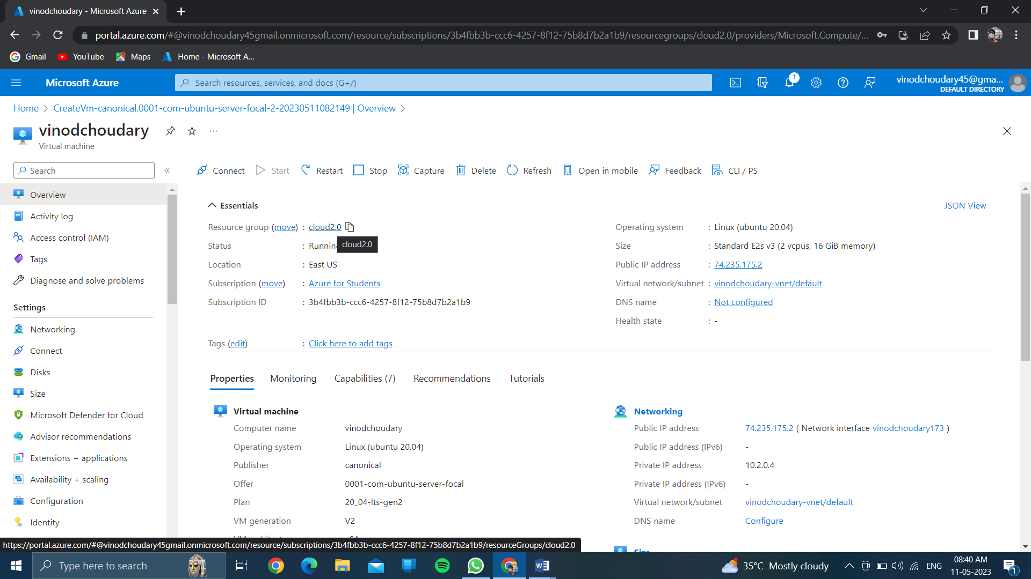

And click on << back to home >>

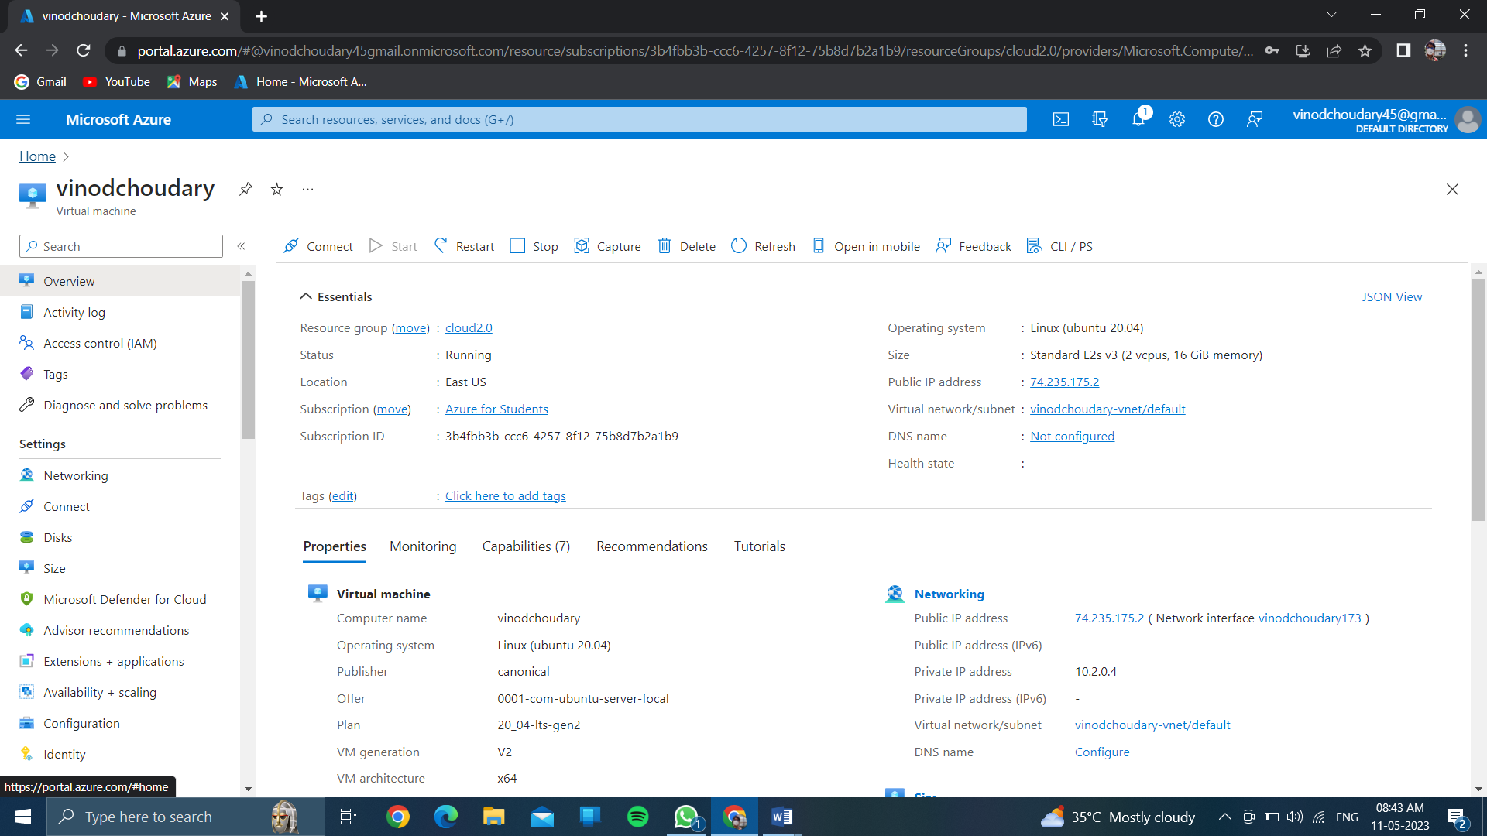

Now see your resource group and vitual machine is created….

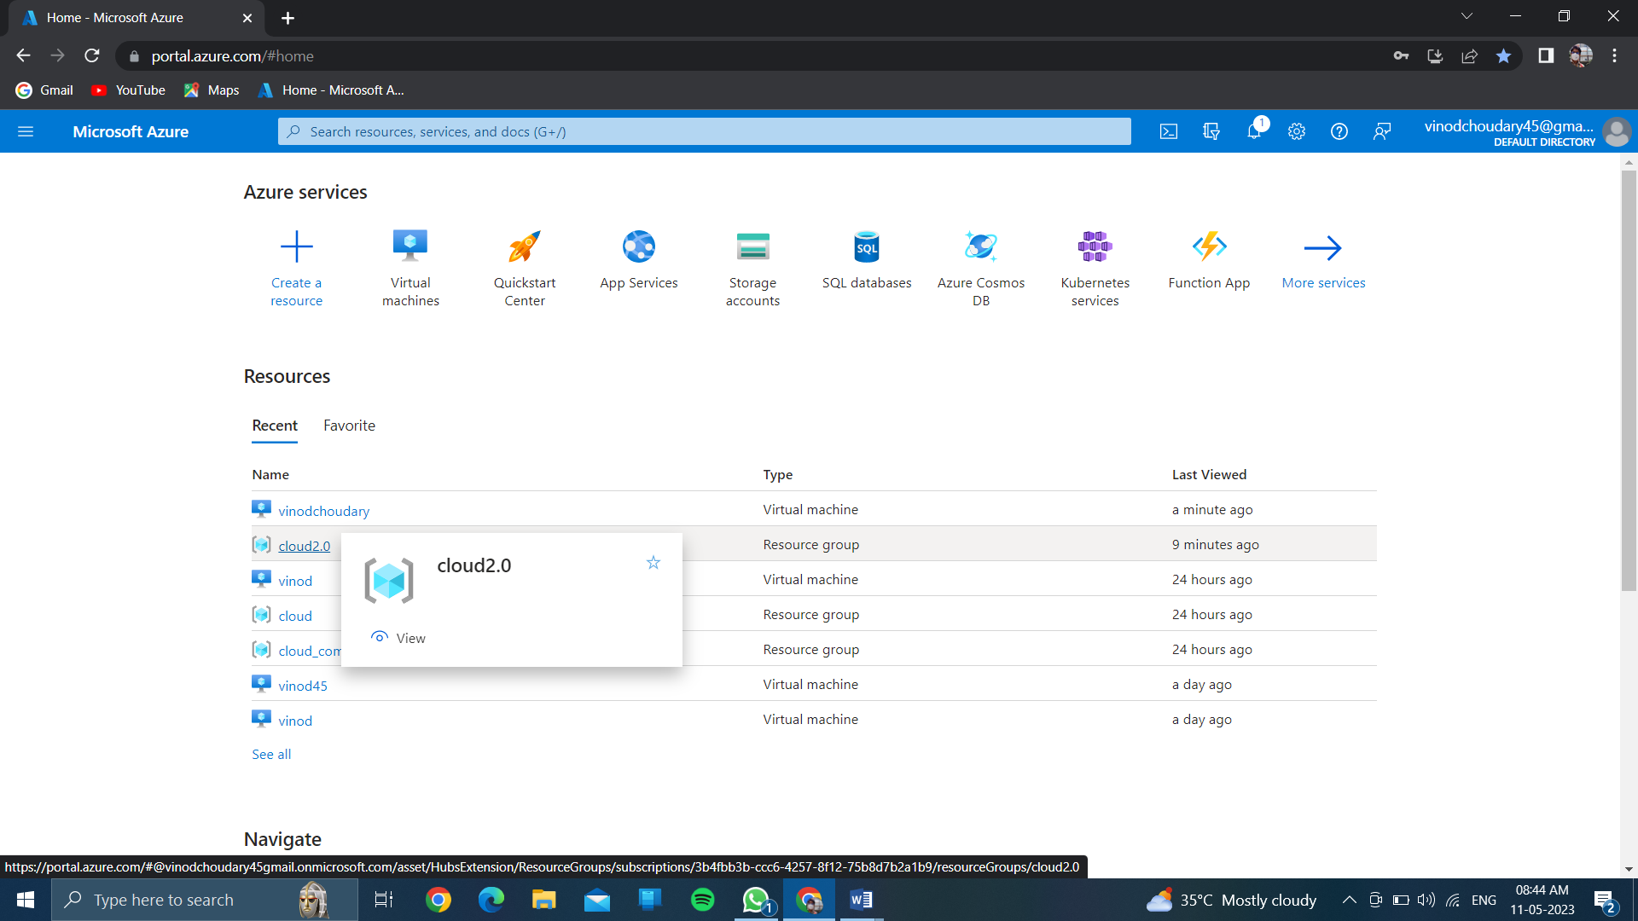

Click on name of the virtual machine…..

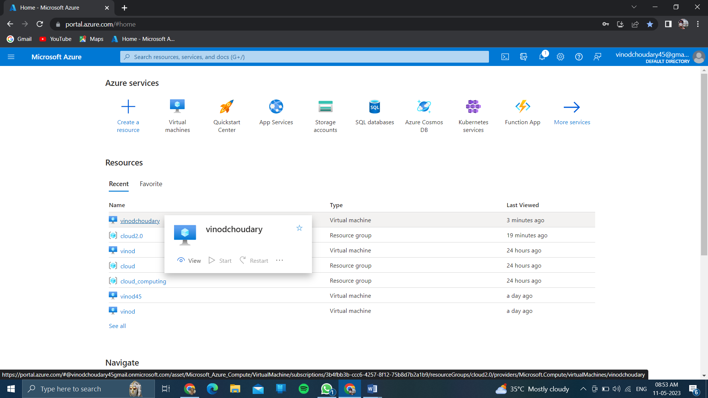

Now you can see your name of your vitual machine….

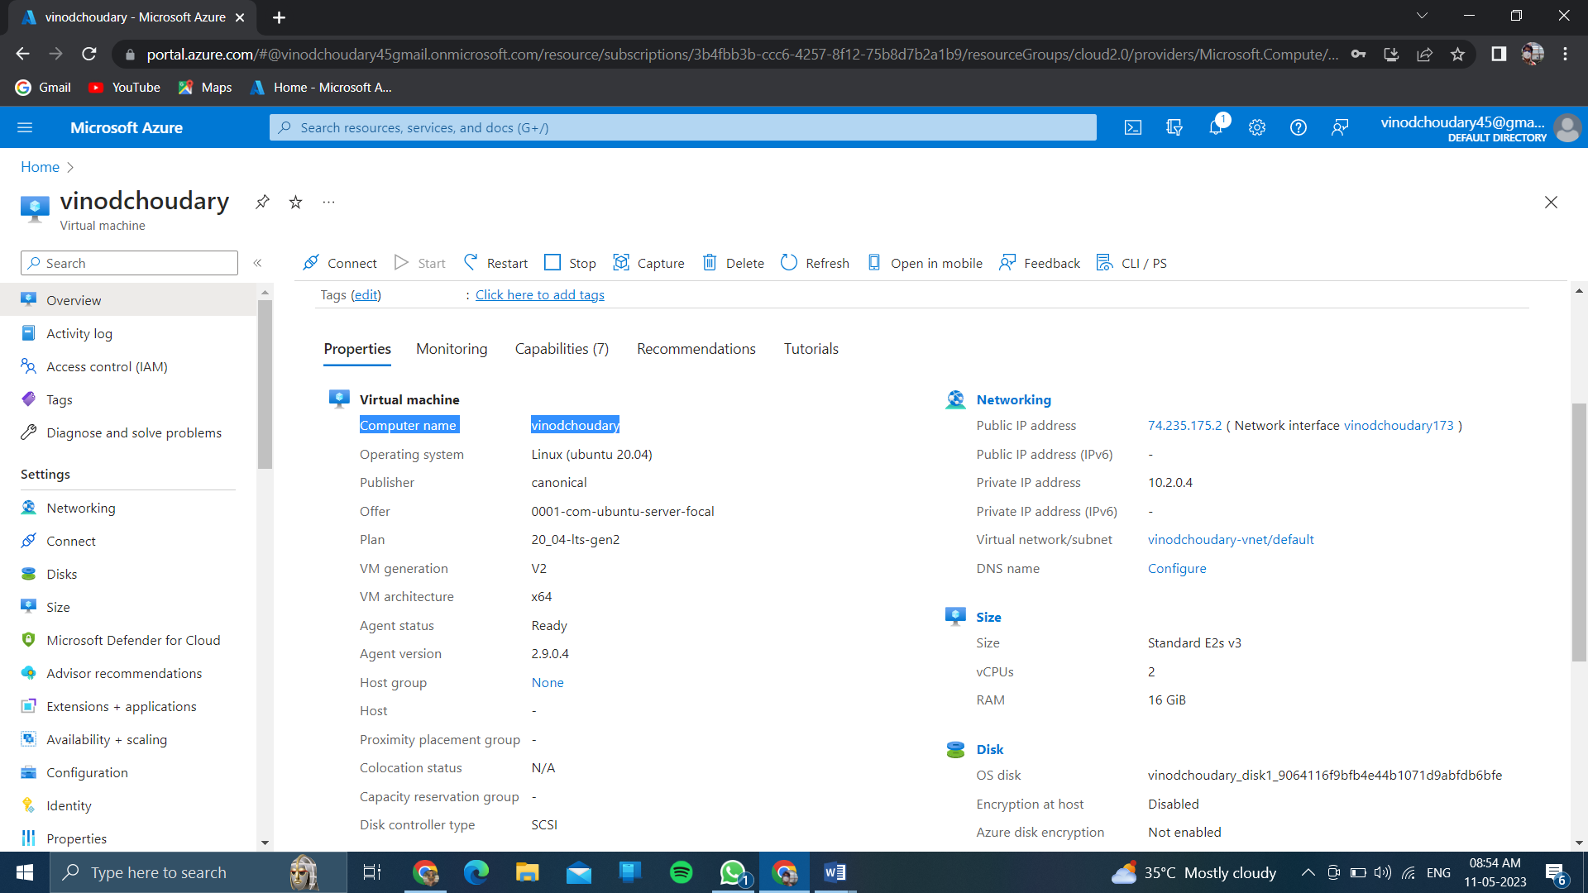

Click on <<connect>>

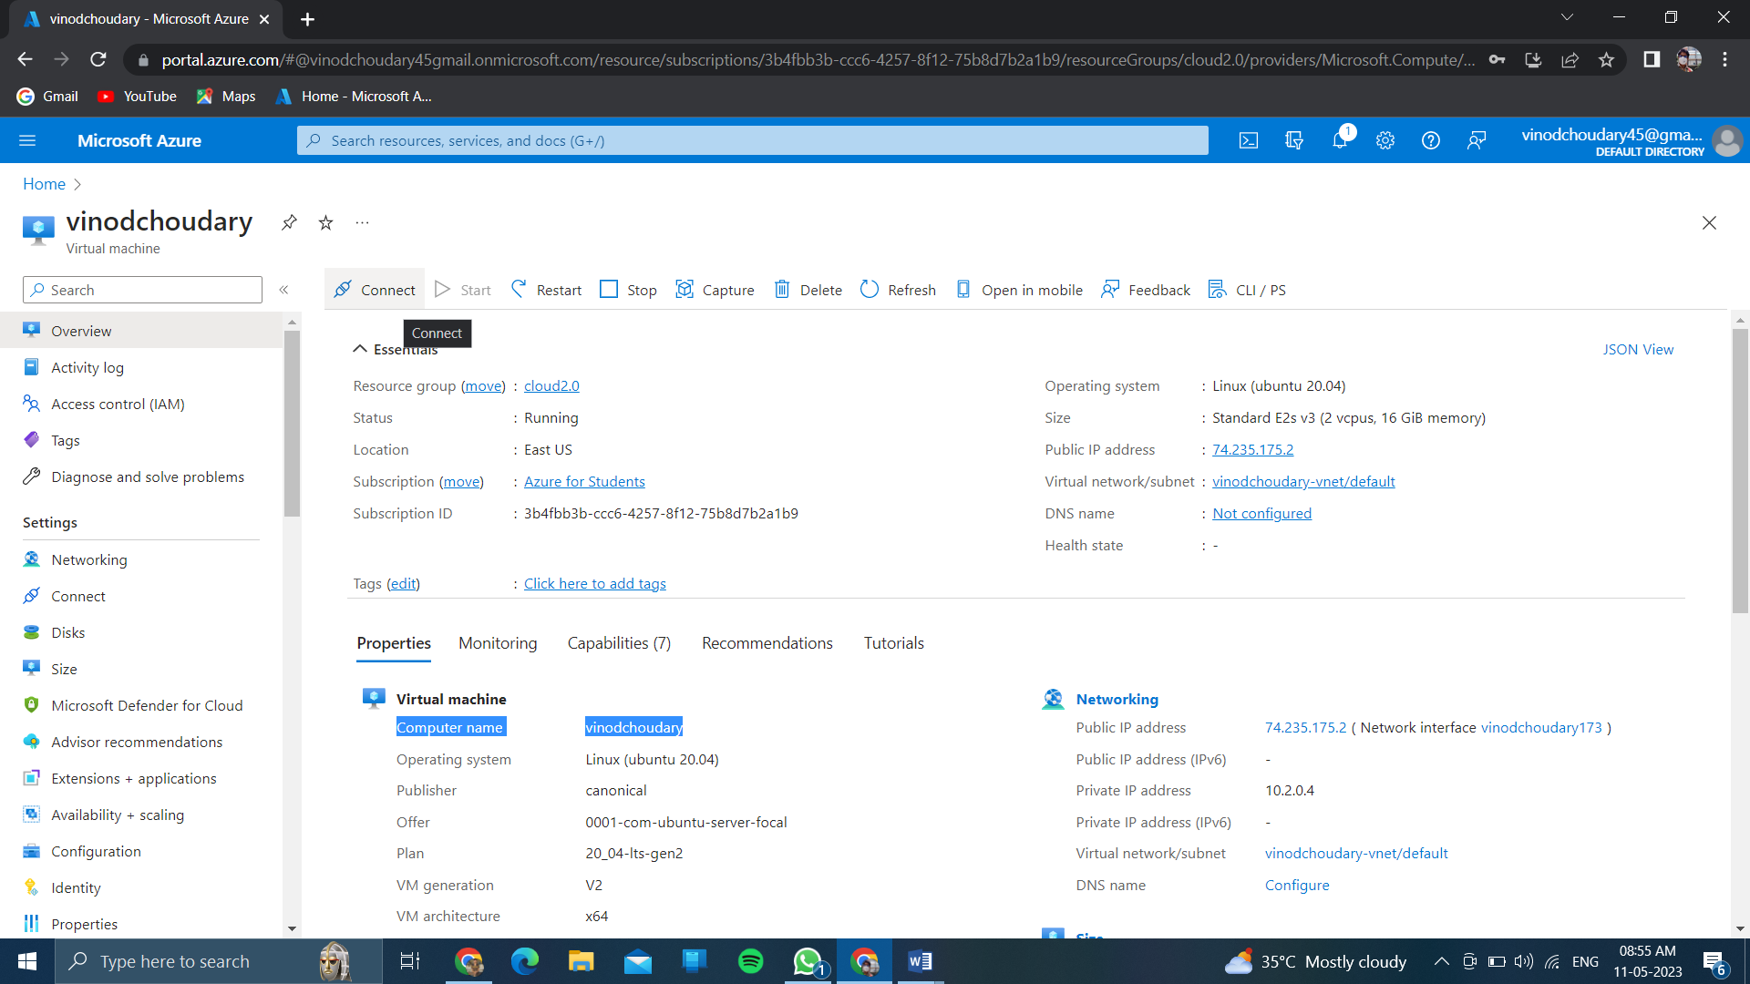

And wait for few minutes for checking the network security of client ip –address in ssh….

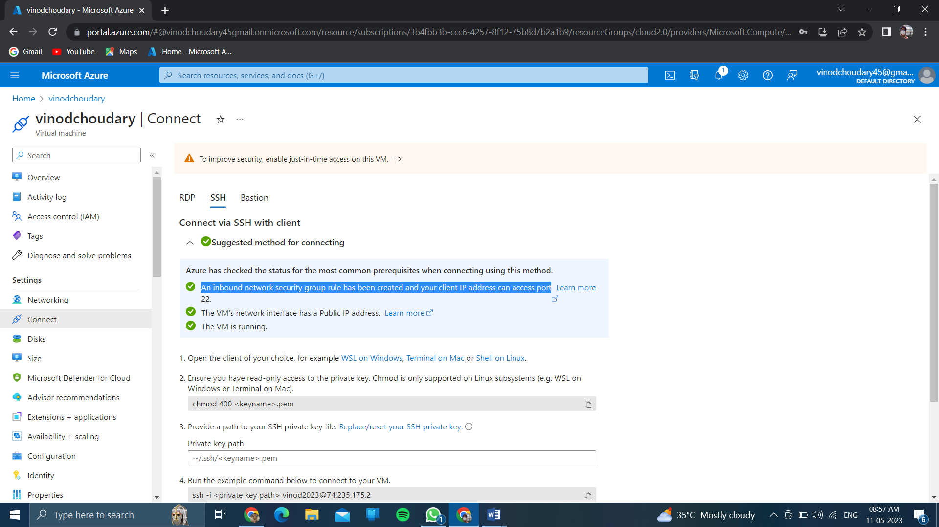

Click on rdp ….<<download>>RDP file…..

After then open the rdp file and you will get the interface…

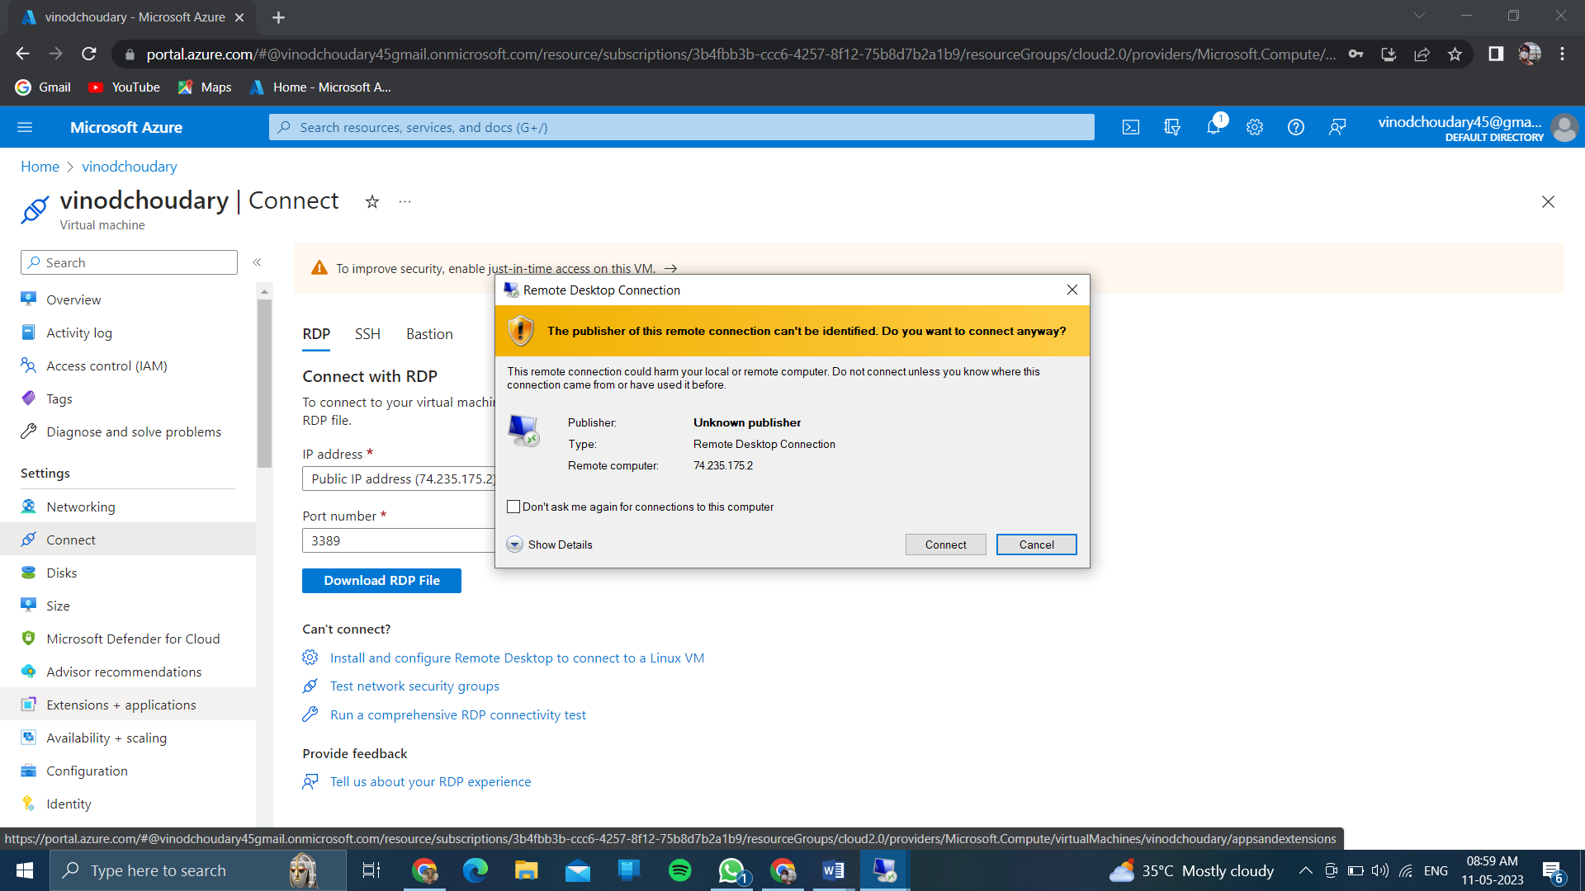

Then click on connect….

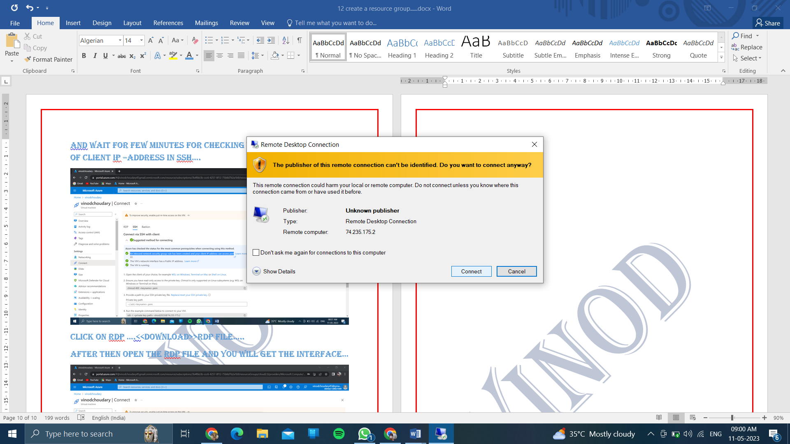

Then after you will get output …..or otherwise you will get

The remote connect desktop…

